4th Grade School Supply List – 2022-2023
1. Students will be switching classes and bringing their supplies with them ALL DAY.
They need a sturdy backpack that will last them all year:
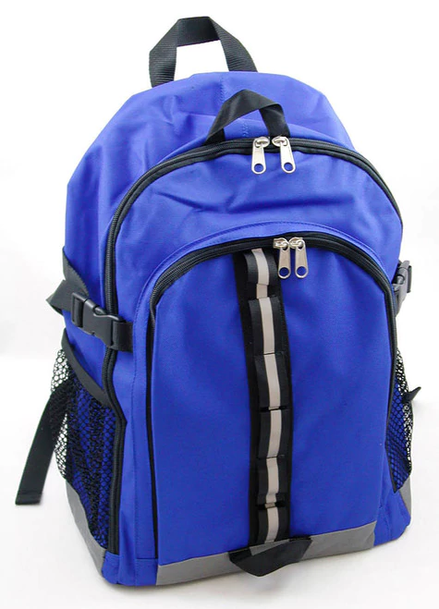
2. Students will be sharing the following supplies with their homeroom:
2 packs of white copy paper | 3 boxes of tissues | 2 rolls of paper towels | 2 pack of index cards  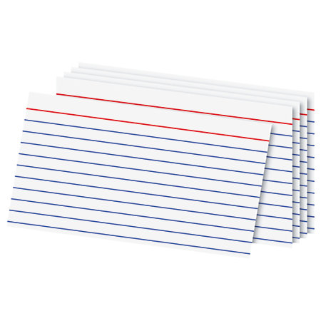
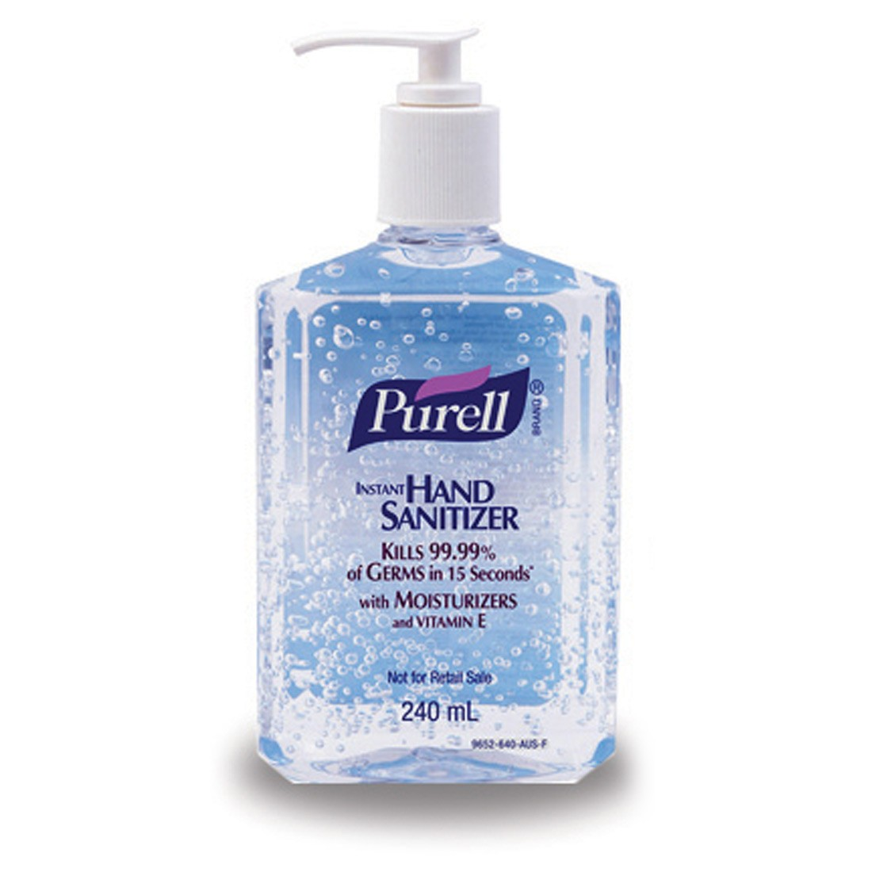  1 bottle of hand sanitizer | 1 pack of wide-lined loose leaf paper  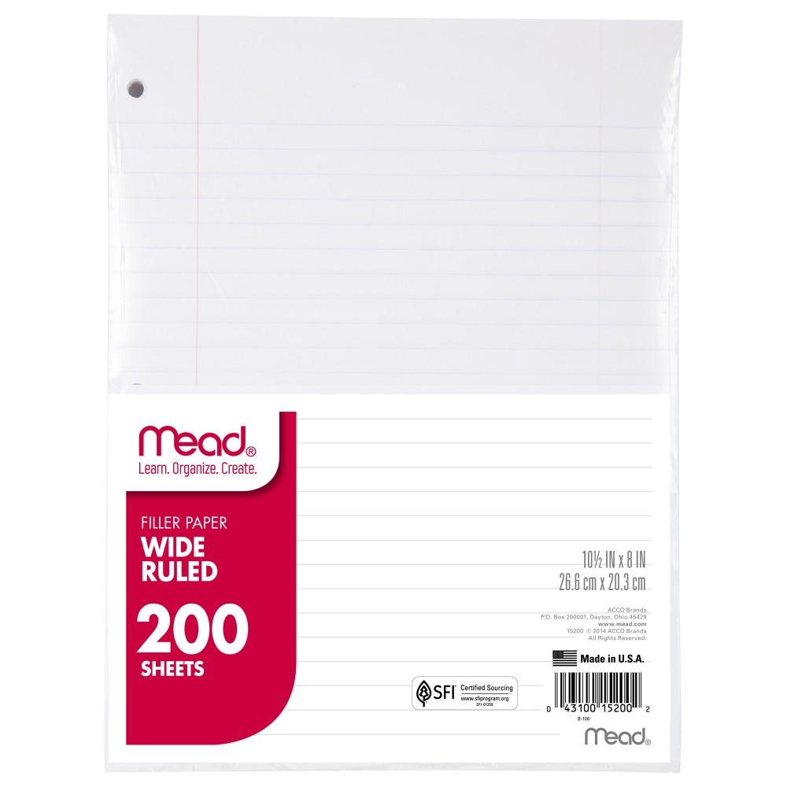 | 1 container of disinfecting wipes  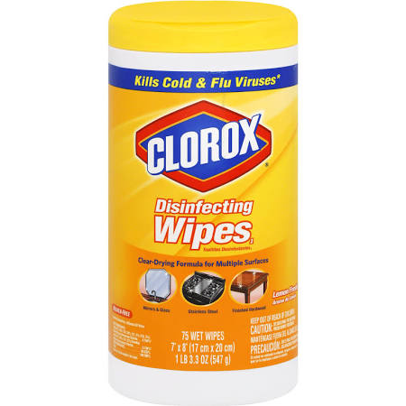 | 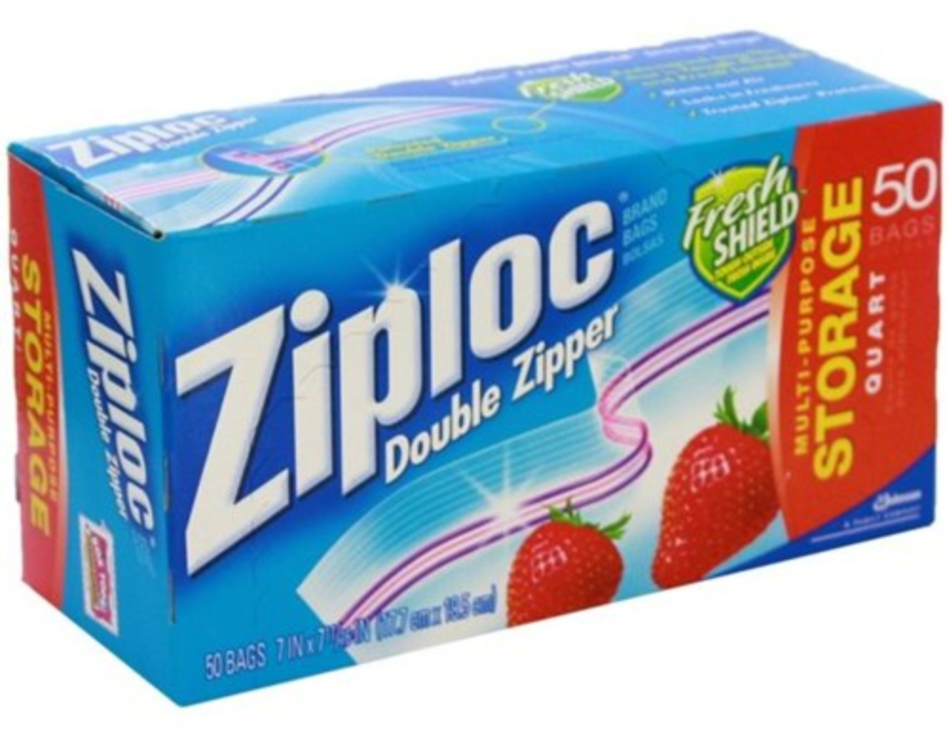  1 box of quart-sized Ziploc baggies
1 pack of glue sticks
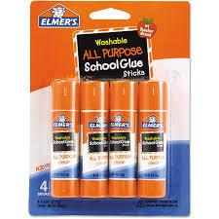

3. Students should have these supplies every day:
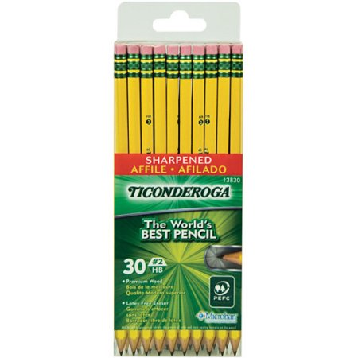  3 packs of #2 pencils sharpened | 1 pack of pink erasers  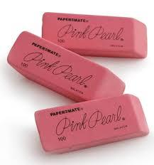 | 2 boxes of crayons  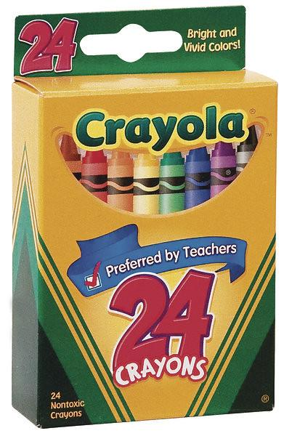 | 1 pack of colored pencils  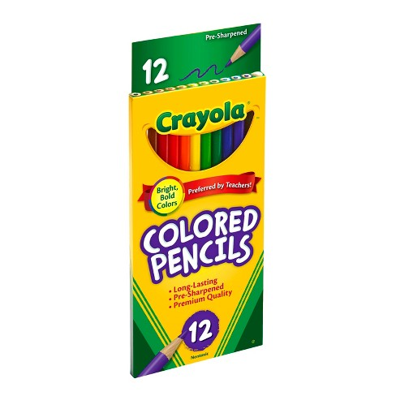
1 box of washable markers  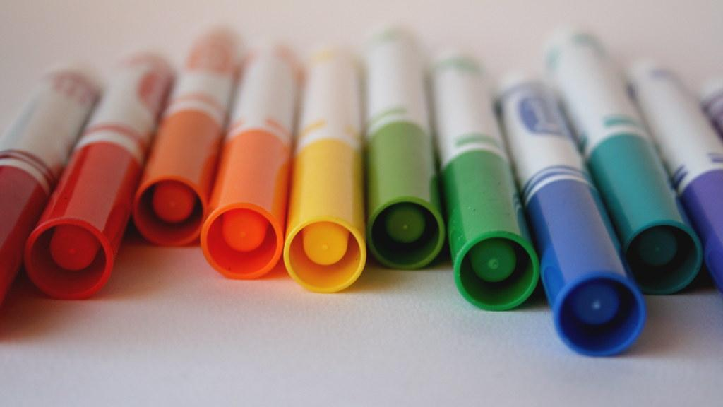 | 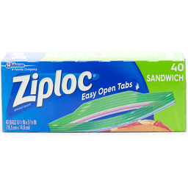  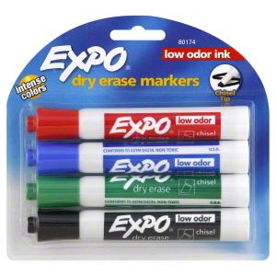  2 packs of Expo markers | 1 wipe off board eraser or clean sock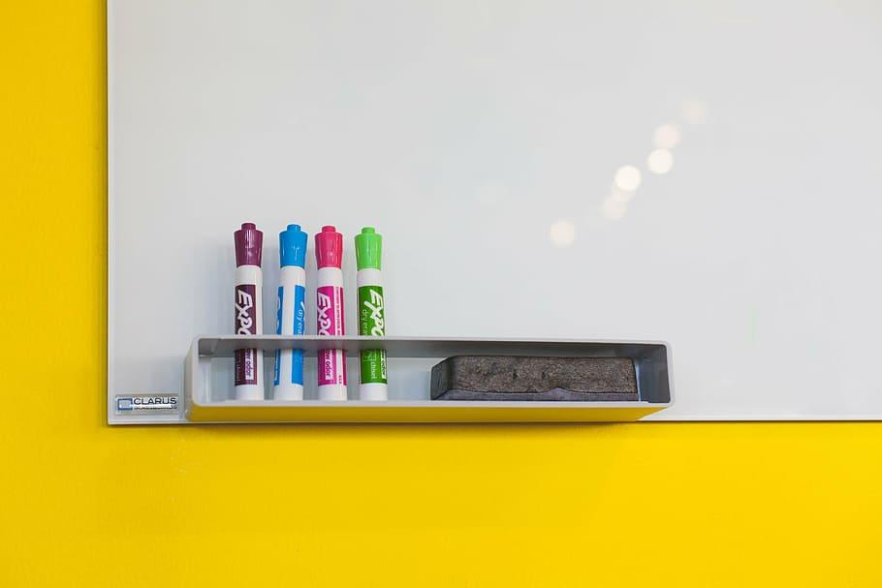 | 1 large pencil case  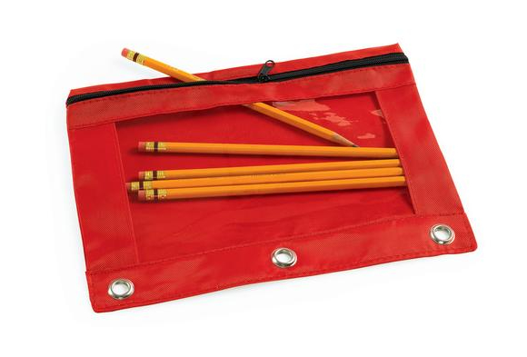
1 pencil sharpener | 4 spiral notebooks  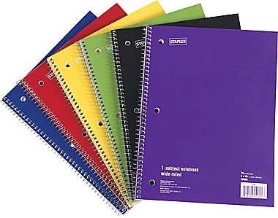 | 4 wide-lined composition books  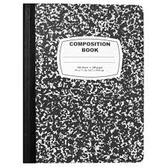 | 5 plastic, plain colored folders  (1 Red - Reading, 1 Purple - Writing, 1 Green - Math, 1 Blue - Science, 1 Yellow - Social Studies)  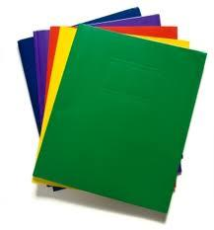
1 pair of headphones or earbuds kept in a baggie with name on it  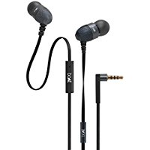 | 1 pair of blunt scissors  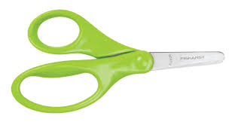 | 1 ruler with inches and centimeters | **optional**  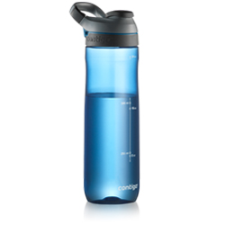  water bottle

Thank you! Gracias! Xie Xie! Tarimah Kasih! Cam o’n! Merci!
The 4th Grade Team

