Hi. My name is Maestra Andrea and I will be your 7th and 8th grade ELA/SLA and Science teacher. I am VERY excited to teach your students. I love 8th grade independence, and I look forward to preparing your students for high school.

Supplies

6 Composition Notebooks  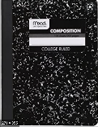 | $10 for subscriptions (website and magazine)  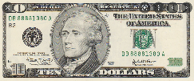
Headphones  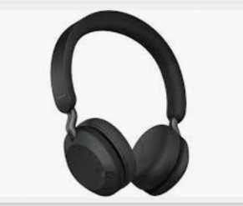 | Kleenex  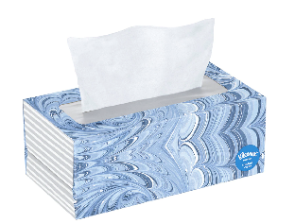
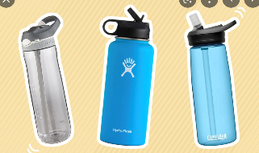  1 reusable water bottle | Mini pencil sharpener  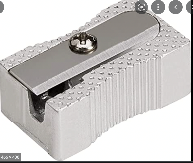
Dry-erase markers  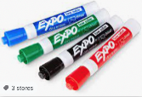 | 3 boxes presharpened #2 pencils  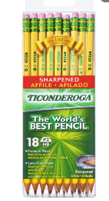
Highlighters  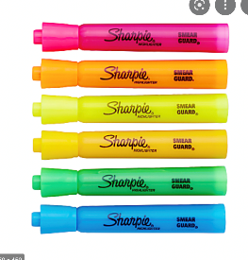 | Scissors  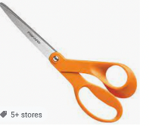
2 containers Clorox wipes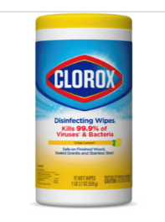 | 2 3-ring notebooks (2-3 inches)  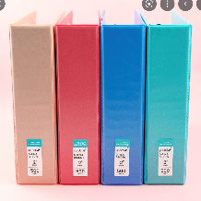
1 ream lined paper | 1 ream computer Paper  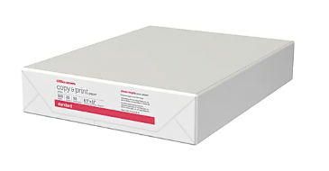
1 box colored pencils  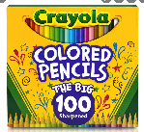 | Sticky notes  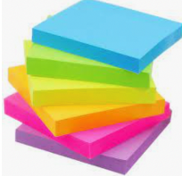

Please contact me at aringklib@philasd.org with any questions or concerns. I look forward to seeing your students on August 29, 2022!

