Ms. Boyden – Rm. 113 - 2022-2023 Kindergarten Supply List:

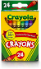
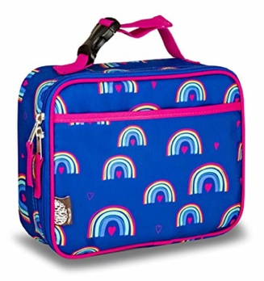

1 backpack 1 lunchbox 1 box of crayons

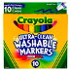
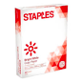

1 box of washable markets 3 packs of white paper
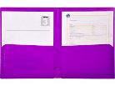
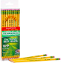

1 box of sharpened pencils. 3 two pocket folders

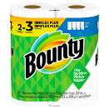
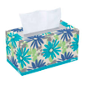

Paper towels 2 boxes of tissues

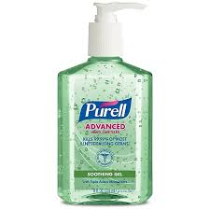
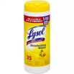

2 Lysol wipes 1 bottle of hand sanitizer

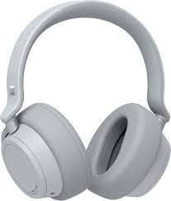

1 pair of headphones

