Mr. Taylor – Rm. 114 - 2022-2023 Kindergarten Supply List:

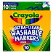
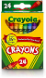

2 boxes of 10 washable markers 1 box of 24 crayons
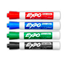
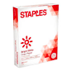

1 box of Expo Dry Erase Markers 3 packs of paper
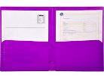
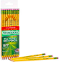

1-2 boxes of sharpened pencils 2 - two pocket folders

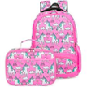
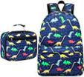

1 pair of Headphones Backpack & Lunchbox

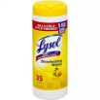
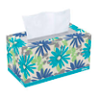

2 boxes of tissues 2-3 Lysol wipes
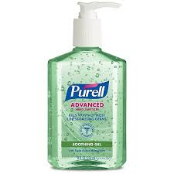
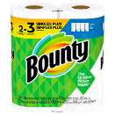

Paper towels 2 bottles of hand sanitizer

